**Snapvault Configuration for Ora Volumes (7 mode)**

**Details:**

|  |  |  |  |  |  |  |  |
| --- | --- | --- | --- | --- | --- | --- | --- |
| **Server : Filer : Vol** | **BCS** | **Size** | BU | **Backup Filer** | **Aggregate** |  | **Retention** |
| c253dvw: prod-ecom-u0103:/vol/ips_tcm860p_s01ora1_snap/s01oradata1 | BCS22653 | 1749 GB |  | fr-nasecombkp-u01 | Aggregate 1 | fr-nasecom-u03.int.thomsonreuters.com | 45 days |

Whenever we receive a request to enable snapvault for Ora Volumes get the BCS details from DB team and proceed below steps.

**Prerequisites before configuring a SnapVault:**

1. **Collect the BCS details from the requester.**
2. **As per BCS collect the BKP retention policy ( in this case 45 days)**
3. **Collect the BKP filer from the same site based on BKP capacity report. Ensure there is adequate space in aggregate.**
4. **If the volume utilization is <1TB we will**

**Steps to get the Retention policy:**

**Click on the below link.**

<https://buildcenter.thomson.com/searchbuildconfigs.asp>

c253dvw: prod-ecom-u0103:/vol/ips_tcm860p_s01ora1_snap/s01oradata1

Give the server name **c253dvw as shown below and click search.**

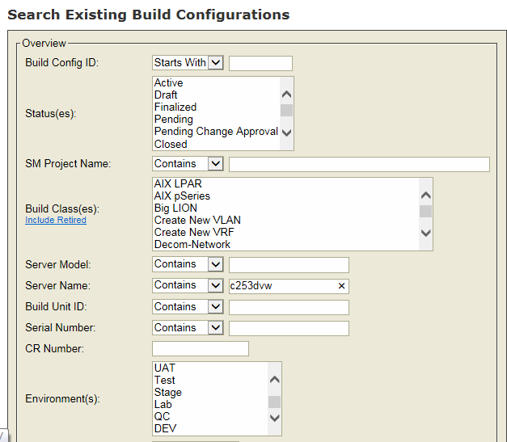

**A new window will open. Search with the Volume name to get the retention policy details.**

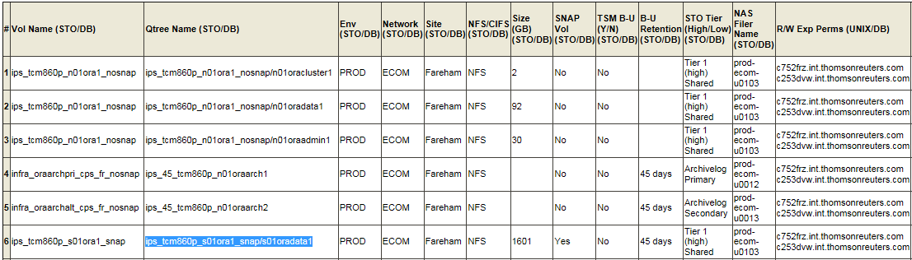

**Note: Make sure that you are collecting the retention policy for the correct volume and host.**

**Step2: Choose the Bkp filer from the same site of Source volume. BKP filer details can be found in daily BKP capacity report.**



**We see that source pfiler is from Fereham Location. So we have to choose the BKP filer from the same site.**

**As per the Backup Capacity report we see there are 2 BKP filers from Fereham location**

|  |  |  |  |  |  |  |
| --- | --- | --- | --- | --- | --- | --- |
| FARENHAM | Filer | Aggregate | Total | Utilized | Available | Capacity |
| CIS | fr-nascorpbkp-u01 | aggr1_64 | 58115GB | 38285GB | 19830GB | 66% |
| CPS | fr-nasecombkp-u01 | aggr1_64 | 116230GB | 43275GB | 72955GB | 37% |

**Ecom – CPS**

**Corp -- CIS**

**As our filer fr-nasecom-u03 is pointing to CPS, so we have chosen fr-nasecombkp-u01** as our bkp filer in this case.

Steps to Configure Snapvault ( 7 –Mode)

Before proceeding check if there is any SV relation exists.



Step1: Check the source volume utilization;

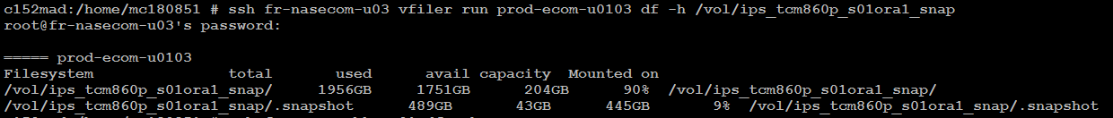

Note:

As per TR standard if the source volume size is

< 1TB -- We create SV with a group volume

>1TB -- We should not create SV with a group volume.

In this case the volume utilization is more than 1 TB. So we are going with the below process.

Step2: Check if there is adequate space in BKP filer aggregate.

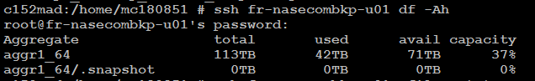

Step3: Create a volume in BKP filer double the size of source volume. The created Volume should be a thin volume.



Note : We need to create the volume name on BKP filer based on the retention policy.

If the source volume is **ips_tcm860p_s01ora1_snap the BKP volume name should be sv_45_ ips_tcm860p_s01ora1_snap.**

**Here 45 stand for BKP retention.**

**-s specifies space guarantee**

**-s none : thin volume**

**-s volume : thick Volume**

**Step4: Check the utilization of the aggregate. As we have created thin volume there should be no change in Aggregate size.**



**Step5: Set Snap reserve to 0.**

**When a volume is created by default it takes snap reserve to 5%. We need to set the snap reserve to 0% as this is aBKP filer and it doesn’t require any backups.**

**Volume utilization before snap reserve is set to 0.**



**Volume utilization After snap reserve is set to 0**



**Step6: Set the snap sched to 0 0 0**



**To avoid Nightly snapshots creation we set snap sched to 0 0 0.**

**Step7: Add the volume to a bkp vfiler**

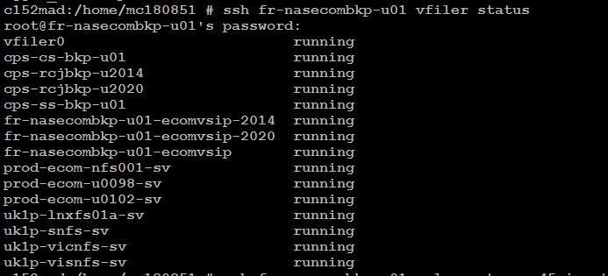

**As per new standard we are configuring to the same site BKP vfiler we need to select cps-ss-bkp-u01**

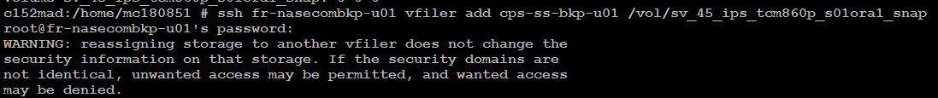

**Step8: Enabling Dedupe**



**Step9: Start Dedupe:**



**Step10: Set the auto size**



**-m -- > Max expandable size**

**-i 🡪 increment of**

**Step11:** Enabling the autosize to grow



**Step12: Start the snapvault relation.**

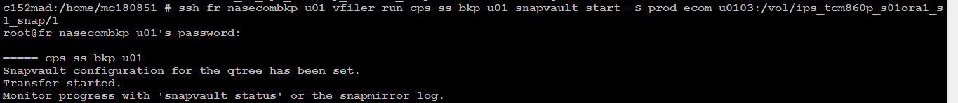

**Step13: Check the Snapvault Status :**



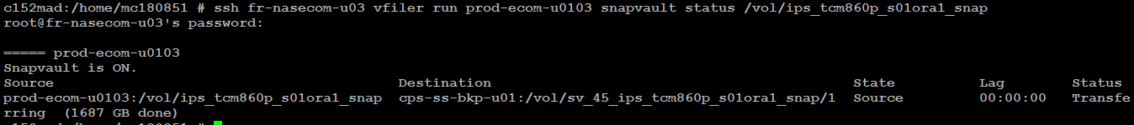

**Once the baseline transfer completes we will create the snapvault schedules.**

**Creating Snapvault schedules:**

**Primary End:**



**Verify the schedule:**



**BKp filer end:**



**Verify the schedule:**



**Note:**

**The schedule on the primary end is for creation of snaps (taking backups) on source volume. As per TR standard source contains maximum of 7 snapshots.**

**The schedule on BKP filer is created for transferring the already existing snaps on source to BKP volume. Here retention is BU specific.**

**7@- 🡪 This specifies we are not taking any manual snapshots from Storage end. DB’s have their script for creating the hot backups.**